**LAKIREDDY BALI REDDY COLLEGE OF ENGINEERING (Autonomous)**

L.B. Reddy Nagar, Mylavaram-521 230. Andhra Pradesh, INDIA

Affiliated to JNTUK, Kakinada & Approved by AICTE New Delhi

Accredited by NBA, New Delhi & Certified by ISO 9001:2015, http://www.lbrce.ac.in

**DEPARTMENT OF ELECTRICAL & ELECTRONICS ENGINEERING**



Course: B.Tech Semester: I Code: **20EE01** Academic Year: 2023-24

Course Title: Basic Electrical & Electronics Engineering Branch: AI&DS B Section

**UNIT-I: DESCRIPTIVE QUESTIONS**

1) Define the following:

(i) Charge (ii) Current (iii) Energy (iv) Power (v) Voltage

2) Derive voltage, current and power relations in R, L & C elements.

3) Determine the total current in the circuit given below:

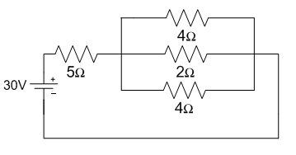

4) Determine the current in all resistors in the below circuit using Kirchhoff’s current law.

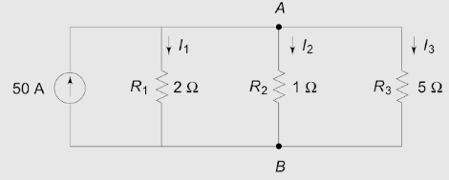

5) Determine the current passing through 3 ohm resistor using superposition theorem.

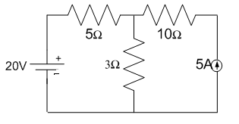

6) Determine the following parameters of a voltage v = 200 sin314t.

(i) Frequency (ii) Form factor (iii) Peak factor

7) Determine the average value and rms value of the waveform shown in the fig.

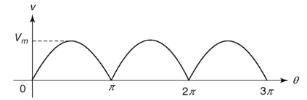

8) Derive the values of Average, RMS value, peak factor and form factor of sinusoidal waveform.

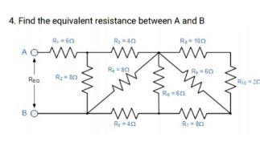9)

10) Calculate the Total Impedance, phase angle and draw the phasor diagram for (I) series RL (II) series RC (III) series RLC circuits.

11) What are the various powers in electrical circuits, and what is their relationship?

|  |  |  |  |
| --- | --- | --- | --- |
|  |  |  |  |
| COURSE INSTRUCTOR | COURSE COORDINATOR | MODULE COORDINATOR | HOD |
| Dr. AVGA.Marthanda | Dr. AVGA.Marthanda | Dr. G.NAGESWARA RAO | Dr. J.S.V.Prasad |